|  |
| --- |
| Name: J.A. Mujeeb |
| Student Reference Number: 10707284 |



|  |  |  |
| --- | --- | --- |
| Module Code: CNET343SL | Module Name: Distributed Systems | |
| Coursework Title: Weather Reporting System Proposal | | |
| Deadline Date: 03/12/2021 | | Member of staff responsible for coursework: Mr. Pramudya Thilakaratne. |
| Programme: BSc (Hons) Plymouth Software Engineering | | |
| Please note that University Academic Regulations are available under Rules and Regulations on the University website [www.plymouth.ac.uk/studenthandbook](http://www.plymouth.ac.uk/studenthandbook). | | |
| Group work: please list all names of all participants formally associated with this work and state whether the work was undertaken alone or as part of a team. Please note you may be required to identify individual responsibility for component parts.  J.A. Mujeeb – 10707284  G.M.D.D. Ratnayake – 10707351  S.O. Perera – 10707315  N. S. De Alwis – 10707160  M. D. A. Medhavi – 10707278  P. P. L. Dilhani – 10709402  ***We confirm that we have read and understood the Plymouth University regulations relating to Assessment Offences and that we are aware of the possible penalties for any breach of these regulations. We confirm that this is the independent work of the group.***  Signed on behalf of the group: J.A. Mujeeb | | |
| Individual assignment: ***I confirm that I have read and understood the Plymouth University regulations relating to Assessment Offences and that I am aware of the possible penalties for any breach of these regulations. I confirm that this is my own independent work.***    Signed: | | |
| Use of translation software: failure to declare that translation software or a similar writing aid has been used will be treated as an assessment offence.  I *have used/not used translation software.  If used, please state name of software………………………………………………………………… | | |
| **Overall mark _____% Assessors Initials ______ Date_________** | | |

*Please delete as appropriateSci/ps/d:/students/cwkfrontcover/2013/14

# Introduction to The Distributed System –

The use of weather reporting in day-to-day life is very important. Its utilization could greatly influence the outcome of a scenario. It could be something as simple as deciding whether you should take your umbrella on your way out, or even as major as handling cultural operations, agriculture and farming or livestock protection implementations.

With Sri Lanka’s weather rapidly varying, weather can transition from largely homogeneous temperatures to torrential rain in a heartbeat. With the adaptation of unexpectedly frequent changes, it is crucial to make sure to be prepared.

Sri Lanka is liable to prevailing and predictable effects of climate change. Preceding natural disasters (such as tsunamis, floods, landslides, droughts, and cyclones) can greatly substantiate this. Profoundly weather-sensitive sectors in Sri Lanka include transport, agriculture, construction, energy, and disaster risk management.

It is important to note that even with weather stations, live broadcasts, and television/radio stations existent, not all are aware of the continuously differentiating weather conditions.

The impacts and effects of climate change could invite climate change-induced hazards and disasters. The unawareness of weather reports may affect the lives of many. Thousands of citizens are prone to being affected by the threat of climate change. They may find themselves in life threatening situations. Weather prediction is essential in order to provide citizens with pragmatic information. Furthermore, this also aids in the reduction of weather-related losses, personal safety and health, enhancement of societal benefits and in supporting economic prosperity.

It is abundantly clear that weather forecasting reports are essential to mitigate the effects civilians getting caught in a severe crisis.

# Introduction to Quick Weather –

**What is distributed system?**

A distributed system is a collection of independent computers that appears to its users as a single coherent system. (Tanenbaum)

We have a system or application that could be a software. In that particular system we have a number of independent computers (individual computers inside the system). These individual computers are doing their own task in the system, but for the end user this looks like one single system. Those computers are doing their own tasks but for the user, they can see everything as one system.

A distributed system is contrived to assist the development process of services and applications. These services and applications are able to manoeuvre a physical architecture that would contain multiple independent processing elements. The processing elements do not share primary memory but do partake in complying with dispatching asynchronous messages via communication network.

Furthermore, Distributed Systems also utilize independent hardware in furtherance of creating a software. It would appear as a complete system all working as a single unit, but in reality, it makes use of multiple computers in contemplation of making a distributed system function.

The primary memory of other hardware elements is not employed by Distributed Systems. Instead, multiple independent processing elements within the hardware are utilized. Through the use of asynchronous messages, they can communicate over a networked communication.

In the following report, our team would like to highlight the main outcome of our system.

To make the reader of this report get a clear idea, we have simply built a web application and a mobile application that will be running as a client application.

People often need to know what the weather around them would be like, but since Sri Lanka is still a developing country, it is only specified in either the news or rather in the radio stations. A weather would mainly focus on the current location of the user, but with Quick Weather, any user can check the weather around the country without having to go through a hassle of signing into the system.

Our main intention is to build a system that will show our users the needed weather for any planned activities in their personal lives.

# Usefulness of the application to the real-world –

Quick weather can perform 02 main functions

1. Users can check weather of any locations and users can do so without having to go through a huge hassle, as it does not require users to register into the system, users can access it without delays. The user simply has to enter the city name where they want to search the weather in and type it in to access weather details.
2. Users can view posts about weather from the web application (ask about desktop), and these updates are done by other people as well.

# Scope of Project –

* High performance
* Amount of scalability of the distribution.
* Web, Standalone and mobile applications.

**Mobile Application as Client -**

Mobile application is created using Android Studio, the language that Android Studio uses is java.

Since Android Studio has SDKs that run emulators, it is rather quick and easy to use. The basic uses that the client can do is:

* The client has the ability to login/signup and post any type of image related to

Technologies used –

1. Laravel
2. Java in web and mobile application both
3. MySQL for the database

**Methodology –**

|  |  |  |
| --- | --- | --- |
| keyword | category | description |
| Java NetBeans | IDE |  |
| Laravel | Framework |  |
| Android Studio | IDE |  |
| MySQL | IDE |  |
|  |  |  |
|  |  |  |

**Database: PhpMyAdmin MySQL –**

**Gantt Chart –**

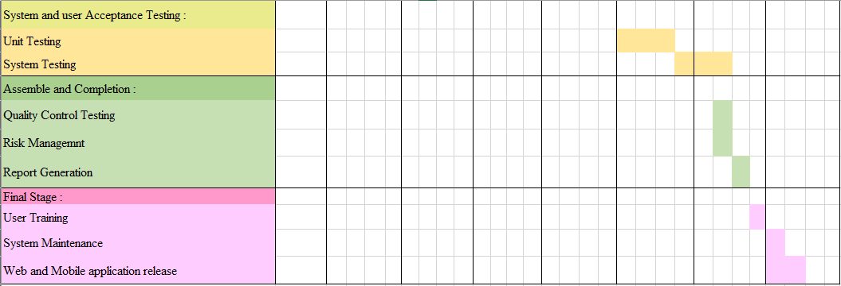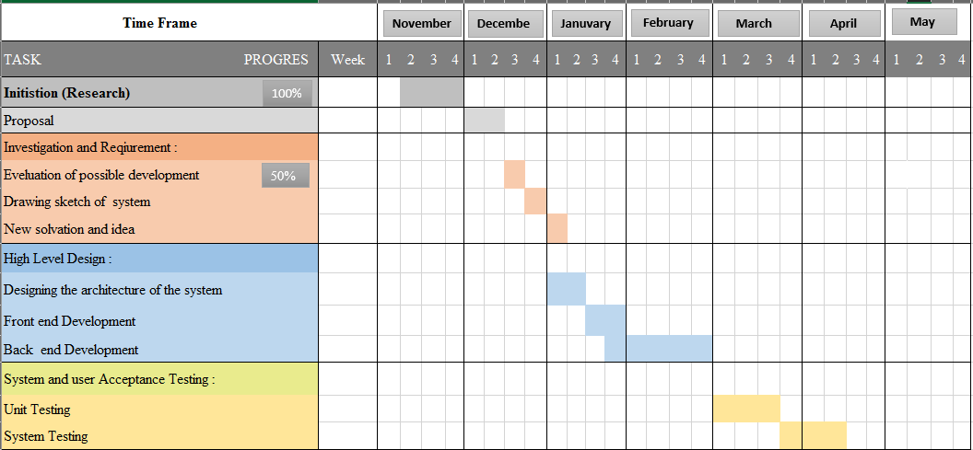

**Selection of Middleware**

**Technical Diagram**

* **Overview of Technical Diagram**
* **Technical Architectural Diagram**

**Load Balancing**

* **With Load Balancing**
* **Without Load Balancing**

**Tolerance to Network Failure –**

As our system run in 3 servers beside the load balancer, just in case of a network failure it automatically masses to the backup server, thus no network failures can have an effect on the system function.

**Load Balancer**

**System architectural Diagram**

**User Requirements –**

The Graphical User Interface system is designed in a way where the user can:

* Users can check weather without having to sign up/sign into the system.
* The users just have to enter the city name of the preferred place where they want to know the weather of.
* The weather will be displayed in an instance for the user to view.
* Users also can check posts that are posted by other members of society.

**Functional Requirements –**

* We tend to run multiple copies of each element on totally different machines.
* Replicate data so single machine failure doesn't cause loss of data. Continues to figure.
* The system runs elements on separate machines.
* Has redundancy at all layers.

**API / Middleware Justification**

**Software components used**

**Distributing the system**

* **Distributed File System**

**Issues faced and actions taken –**

|  |  |
| --- | --- |
| **Issues Faced** | **Actions Taken** |
|  |  |

**Development phases –**

|  |  |
| --- | --- |
| **Development phases** | **Description** |
| 1. Planning | When it comes to defining a project's boundaries, it is mandatory to consider the potentiality of how largesse the scope can be.  By composing a project plan, a calculation of the spatial sense (timeliness) of the project will be incited. This will include a breakdown of possible tasks, a conclusion of the inherent deadlines and overall time taken to complete the tasks. All necessary requirements are accumulated to determine the sequencing the work, including a creation of an initial project schedule. |
| 2. Analysis | The analysis stage will decipher the system's critical features and requirements. This will establish whether it is worthwhile to develop.  It will also determine a requirement of the possible tools and technologies to be utilized, a potential project schedule, necessary budget estimations, etc. |
| 3. Designing | Designing will aid in roughly determining the shape and form of what must be assembled. It will be utilized in the form of a template. This will dictate the implementation proceedings, software architecture, database, and frontend designs**.** |
| 4. Coding and debugging | Frontend development, Database development, Website creation, and the implementation and development of backend logical coding has been contrived. Correspondingly, a Mobile Application with implemented logical coding and a frontend is generated. In addition, an API to interface and a MySQL database has been created. |
| 5. Testing | Functional testing is executed to see if we are achieving the expected and needed outcomes. All code units in the project have been tested, closely following the unit testing process. Integration Testing has been conducted after Once the system's modules were integrated, the full system was effectuated with end-to-end testing. We have also exercised User Interface Testing. This process would entail checking whether the UIs have been designed in fulfilment of the system's specifications. Furthermore, Load Testing has been carried out as part of non-functional testing to enhance the system's quality. It checked the system's capacity to take load. |
| 6. Deliver the product | Deliver the website, mobile application and report**.** |

**Tasks undertaken –**

* **Screenshots of the website**
* **Screenshots of the mobile application**
* **Screenshots of the Admin panel**
* **Main codes of the website**
* **Main codes of the mobile application**
* **Main codes of the API**

**Future enhancement of the system –**

We as a group would love to upgrade our project if we are to continue on this project, this project is to be used by any person who has access to the internet. With this system people can focus and entail in their safety.

We would like to add features were the user can live forecasts and also, we would love to add reports from weather stations into the systems, were people can be updated.

We would also like to enhance the project more with checking for weather patterns and collecting data for the betterment of human life.

**Risk assessment –**

|  |  |  |
| --- | --- | --- |
|  |  |  |
|  |  |  |
|  |  |  |
|  |  |  |
|  |  |  |

**Quality plan –**

|  |  |
| --- | --- |
|  |  |
|  |  |
|  |  |

**Summary -**

**Individual contribution –**

1. J.A. Mujeeb (10707284) -
2. G.M.D.D. Ratnayake (10707351) -
3. S.O. Perera (10707315) -
4. N. S. De Alwis (10707160) -
5. M. D. A. Medhavi (10707278) -
6. P. P. L. Dilhani (10709402) –

25. Acknowledgement

First and foremost, we’d like to extend our sincere gratitude towards Mr. Pramudya Thilakaratne, our module lecturer. We are extremely humbled and grateful to have been able to receive his mentorship, guidance, and support.

The overall accomplishment of this project demanded a significant amount of guidance from many individuals. As a team, we are extremely fortunate to have had this from start to finish.

Finally, we wouldn’t have been able to successfully complete this assignment without the hard work and assistance of all the team colleagues itself. We all enjoyed working with each other.